# JMeter Listeners: Detailed Explanation with Examples

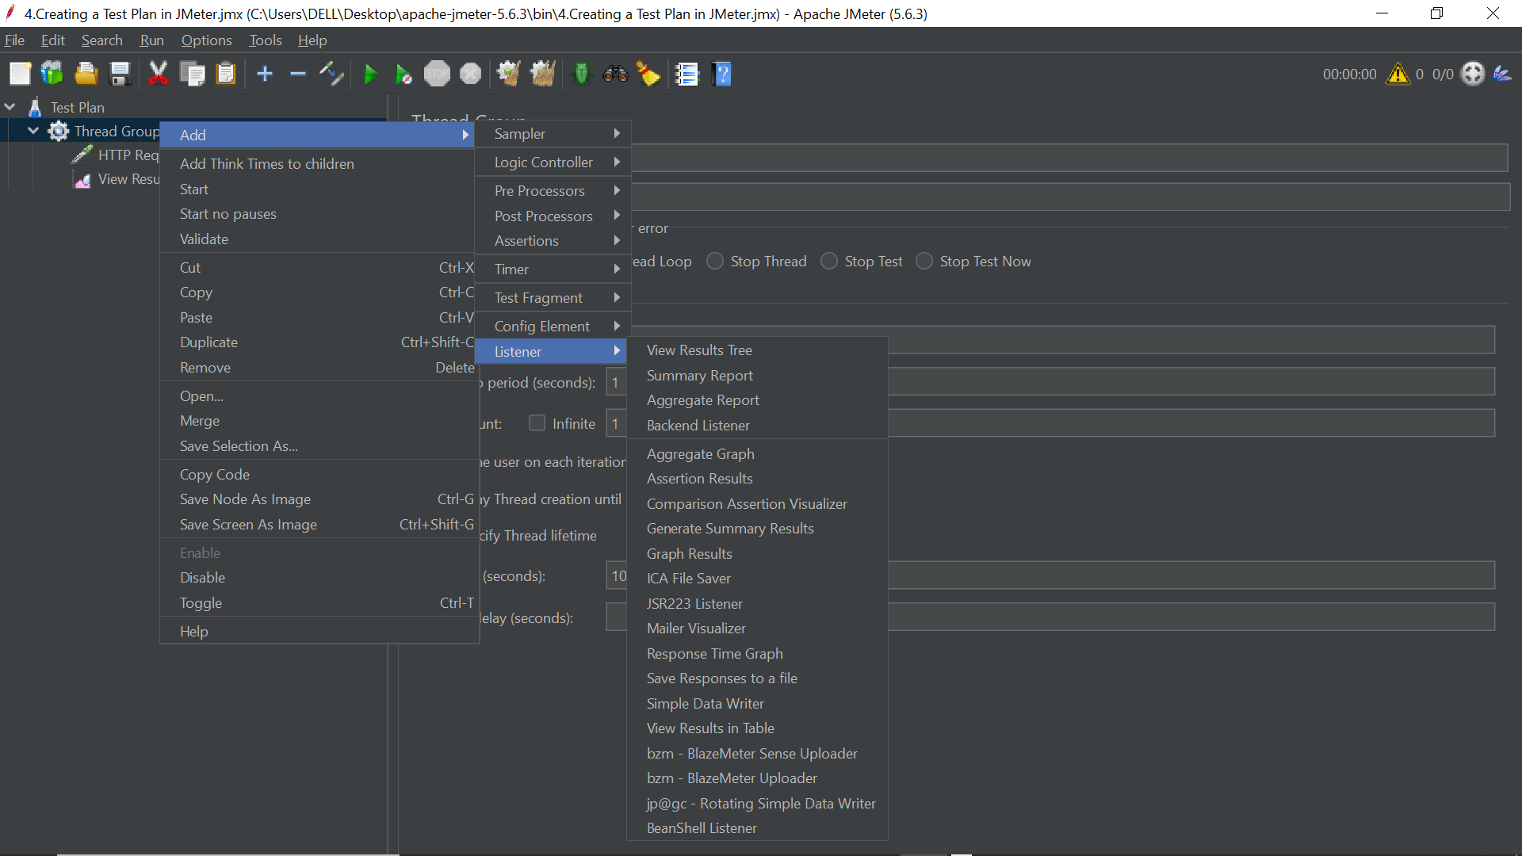

Listeners in Apache JMeter are components that monitor and record the results of test executions. They provide a mechanism for viewing, analyzing, and exporting performance data in various formats. Below is a detailed breakdown of commonly used listeners, what they show, when to use them, and real-world use cases.

1. **View Results Tree**

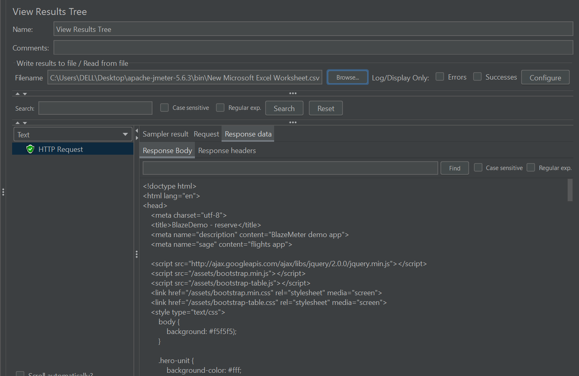

* **What it is:** Essential listener for script debugging. Displays details of each sample.
* **What it shows:**
  + **Sampler Result:** URL, response time, latency, thread name, etc.
  + **Request:** Request headers, body, parameters.
  + **Response Data:** Server's full response (HTML, JSON, etc.).
  + **Response Headers and Assertion Results.**
* **When to use:**
  + Debugging and verifying samplers.
  + Validating extractor configurations.
* **Example:** After setting up a login HTTP request, if the response returns "Invalid credentials," the listener will help identify it and help inspect extractor results for session IDs.
* **Caution:** Don’t use in high-load tests.

1. **Summary Report**

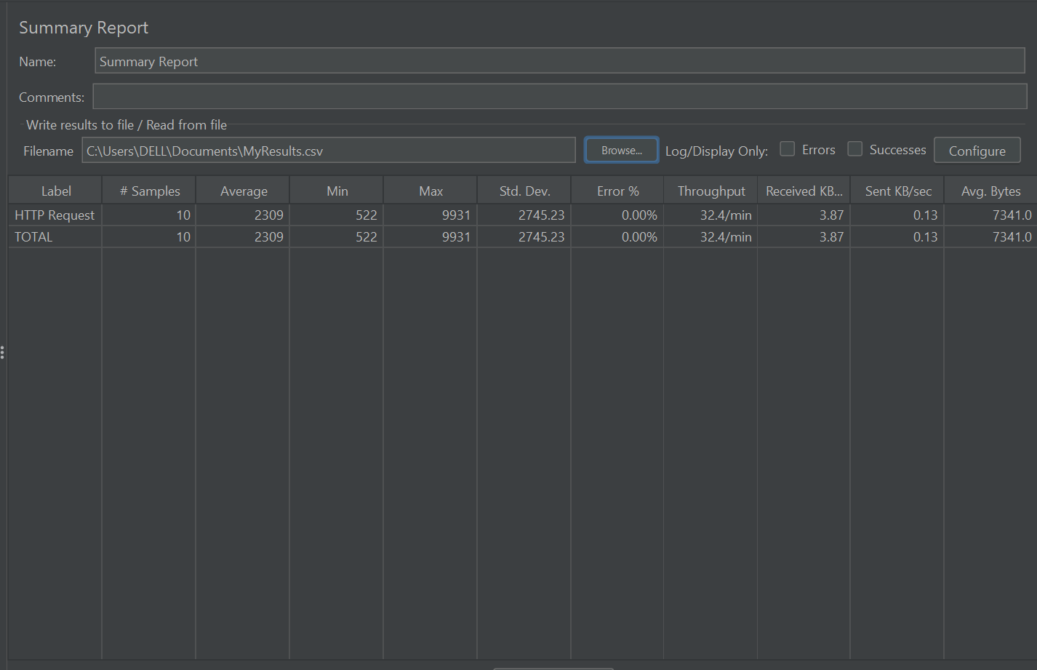

* **What it is:** Tabular overview of test results.
* **What it shows:** Avg, Min, Max response times, #Samples, Error %, Throughput, KB/sec.
* **When to use:**
  + Quick sanity check post-execution.
  + Identify high error or slow response samplers.
* **Example:** After a 30-min test, discover that Checkout has high average response and 5% errors.

1. **Aggregate Report**

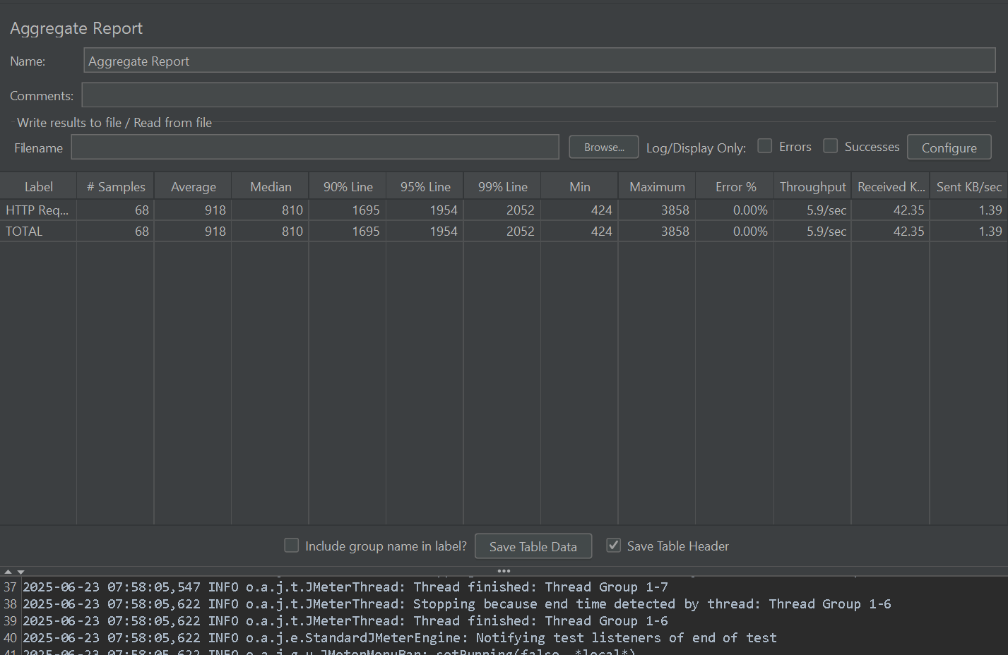

* **What it is:** Summary Report with additional statistical percentiles.
* **What it shows:** All from Summary Report plus 90%, 95%, 99% response time lines.
* **When to use:**
  + SLA verification using percentiles.
  + Highlighting outliers.
* **Example:** SLA: 95% of logins under 1.5s. Report shows 2.1s → investigate.

1. **Backend Listener**

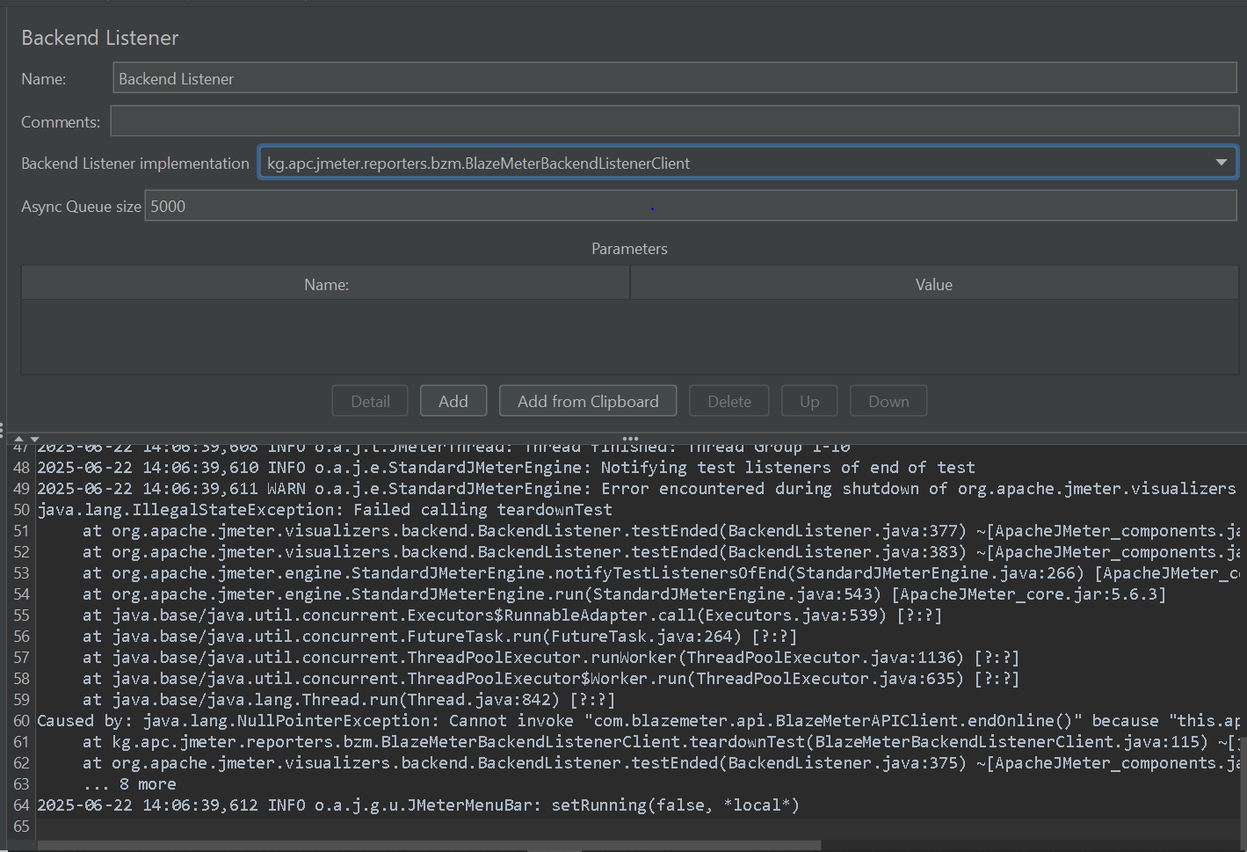

* **What it is:** Sends real-time metrics to external monitoring tools.
* **What it shows:** No GUI output in JMeter; sends raw data to tools like InfluxDB.
* **When to use:**
  + Long endurance/load tests.
  + Distributed or CI/CD testing.
* **Example:** Pushes test metrics to InfluxDB → viewed in Grafana dashboards.

1. **Aggregate Graph**

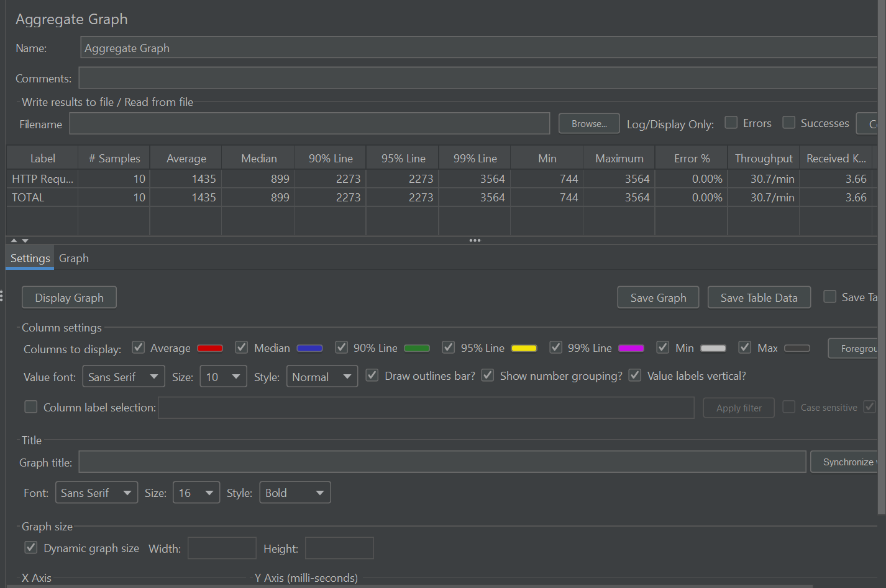

* **What it is:** Graphical visualization of performance.
* **What it shows:** Avg response time and throughput in bar charts.
* **When to use:**
  + Quick performance comparison.
  + Useful in presentations.
* **Example:** Checkout has highest average time → performance bottleneck.

1. **Assertion Results**

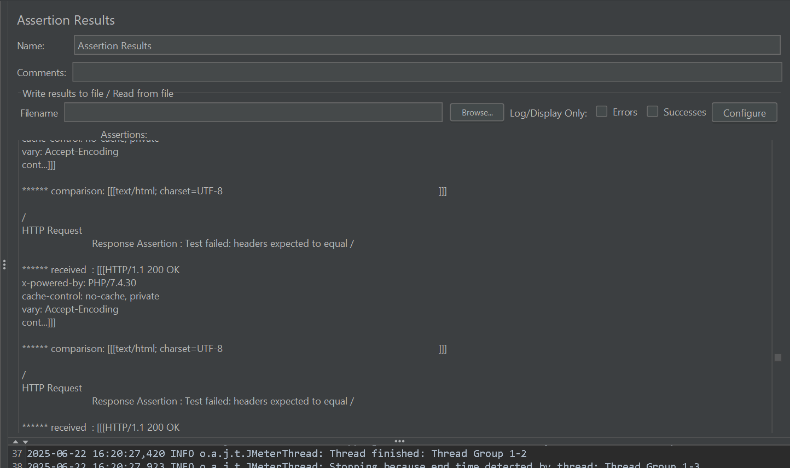

* **What it is:** Shows which assertions passed or failed.
* **What it shows:** Assertion success/failure with messages.
* **When to use:**
  + Debug failing test logic.
  + Functional validation under load.
* **Example:** Text "Welcome, user" is not found → assertion fails.

1. **Comparison Assertion Visualizer (Plugin)**

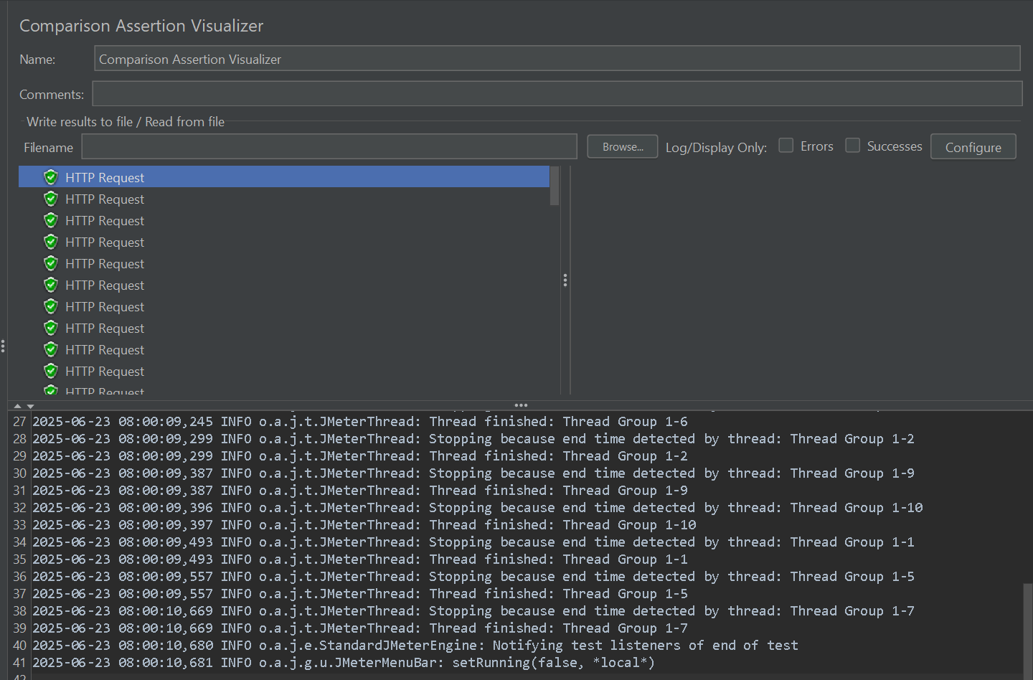

* **What it is:** Visual diff between expected and actual responses.
* **What it shows:** Tree or side-by-side response comparison.
* **When to use:**
  + Regression testing.
  + Identify small but critical content changes.
* **Example:** Product image missing → visually highlighted.

1. **Generate Summary Results**

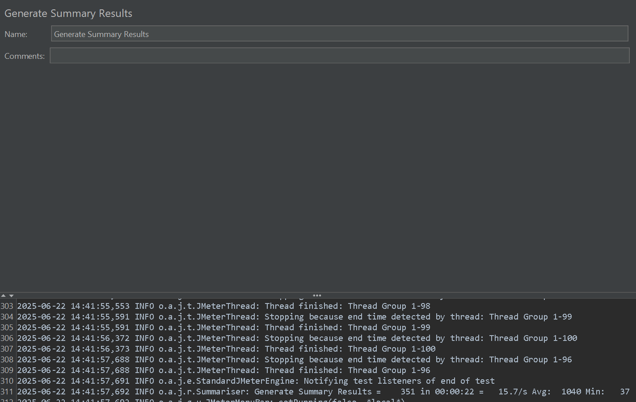

* **What it is:** CLI-friendly listener.
* **What it shows:** Periodic sample summary in terminal.
* **When to use:**
  + Headless/command-line testing.
  + CI/CD logs.
* **Example:** Live TPS, avg response, and error % during CLI run.

1. **Graph Results**

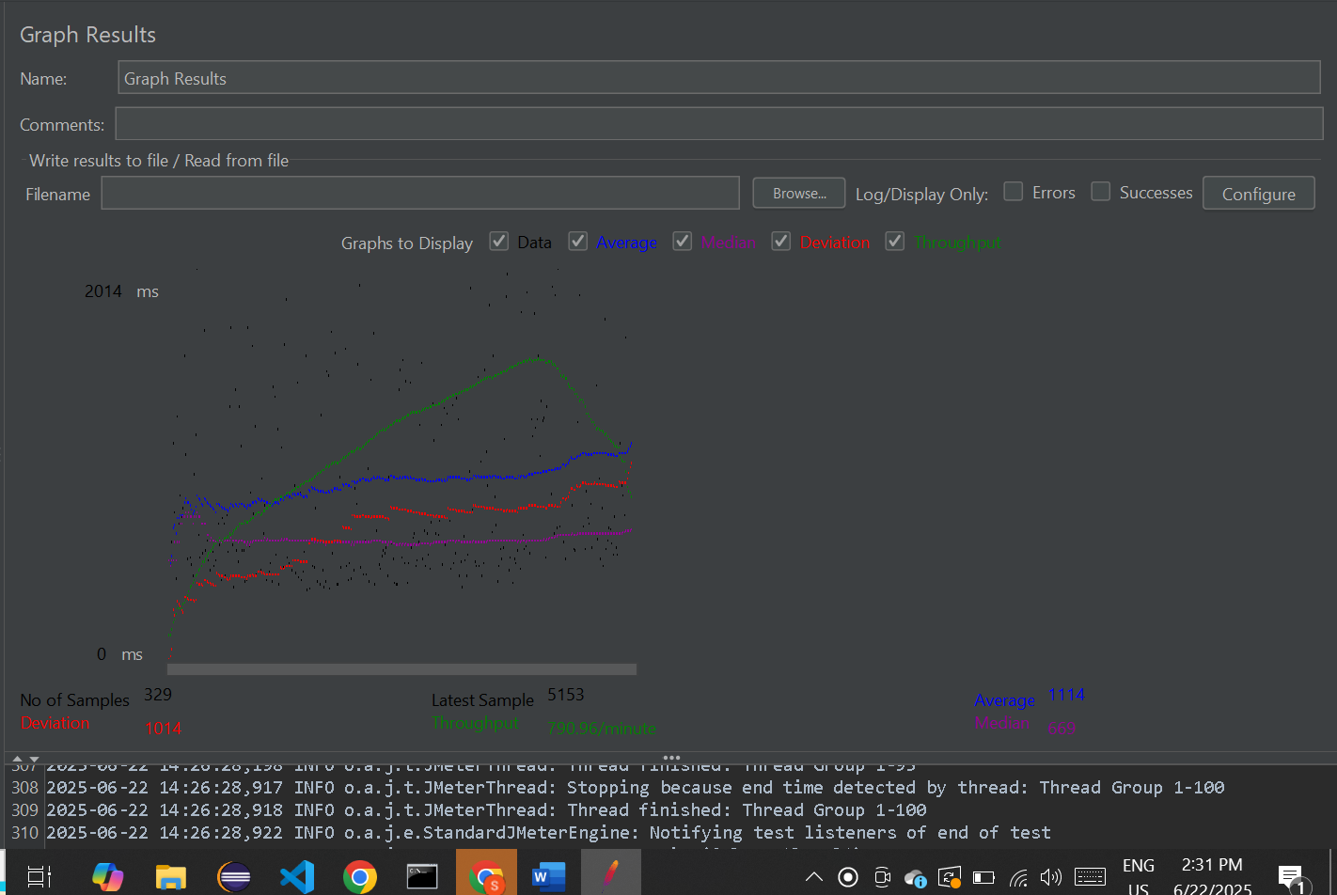

* **What it is:** Time-based line chart of test metrics.
* **What it shows:** Avg, Deviation, Median, Throughput.
* **When to use:**
  + Monitor response time trend.
  + Spot anomalies like memory leaks.
* **Example:** Avg steadily increases → server may have memory leak.

**10. ICA File Saver**

* **What it is:** Citrix-only listener to save .ica session files.
* **When to use:**
  + Citrix performance testing.
* **Example:** Ensures valid .ica files are used in virtual desktop session.

**11. JSR223 Listener**

* **What it is:** Code-driven listener using Groovy, JS, etc.
* **What it shows:** Custom logic output.
* **When to use:**
  + Custom alerts, logging, external integration.
* **Example:** Logs when Checkout > 5s.

**12. Mailer Visualizer**

* **What it is:** Sends email alerts based on result thresholds.
* **What it shows:** No GUI; sends emails.
* **When to use:**
  + Automated alerts for test health.
* **Example:** Error % exceeds 1% → sends alert.

**13. Response Time Graph**

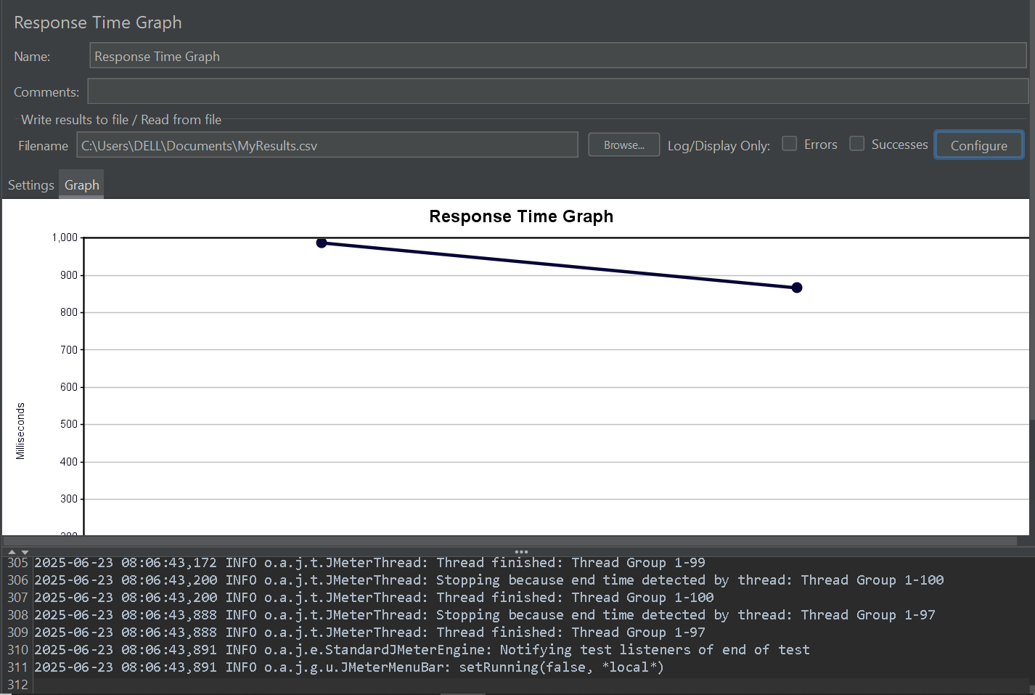

* **What it is:** Line graph per sampler.
* **What it shows:** Average response time trends per transaction.
* **When to use:**
  + Track performance degradation.
* **Example:** Checkout spikes while Login is stable → isolate issue.

**14. Save Responses to a file**

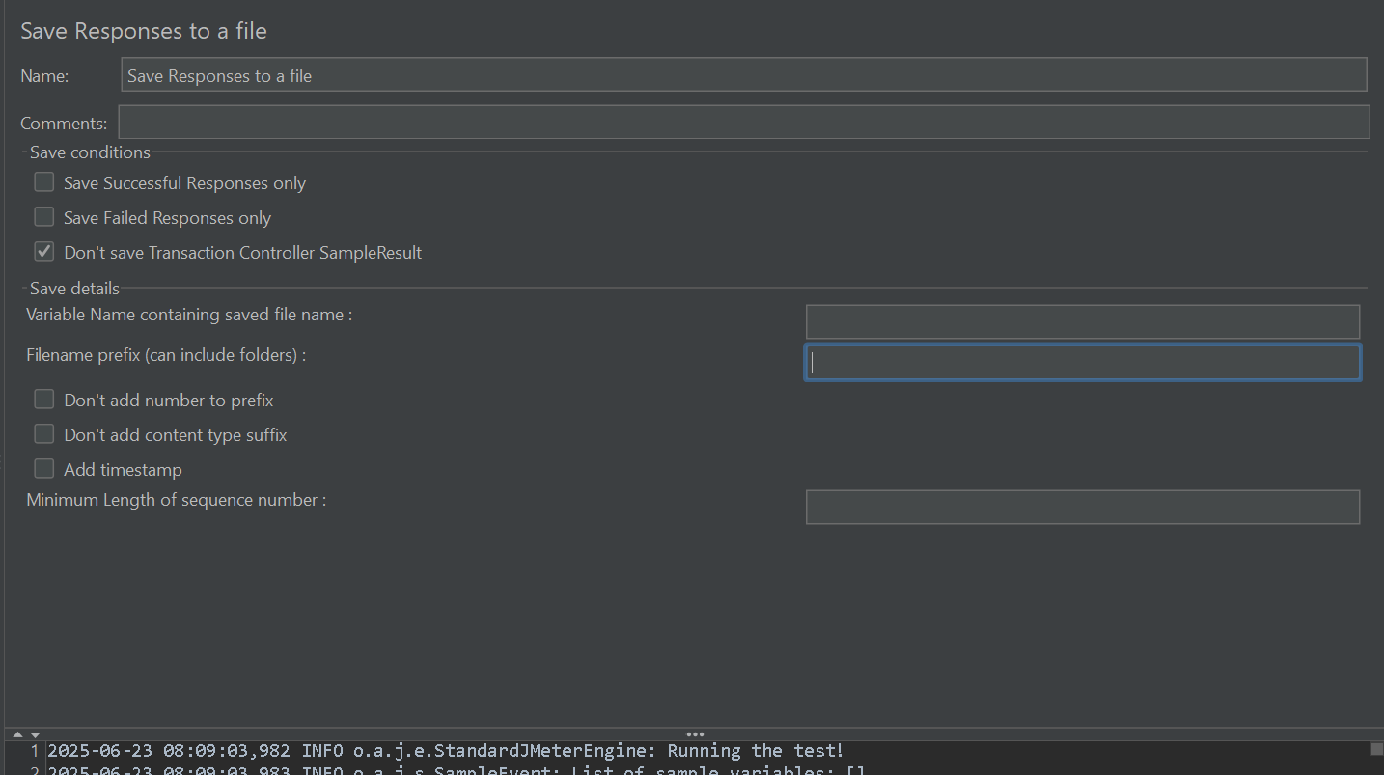

* **What it is:** Writes actual server responses to disk.
* **What it shows:** Raw .json/.html/.xml files.
* **When to use:**
  + Large response debugging.
* **Example:** Store large Checkout API response for later JSON parsing.

**15. Simple Data Writer**

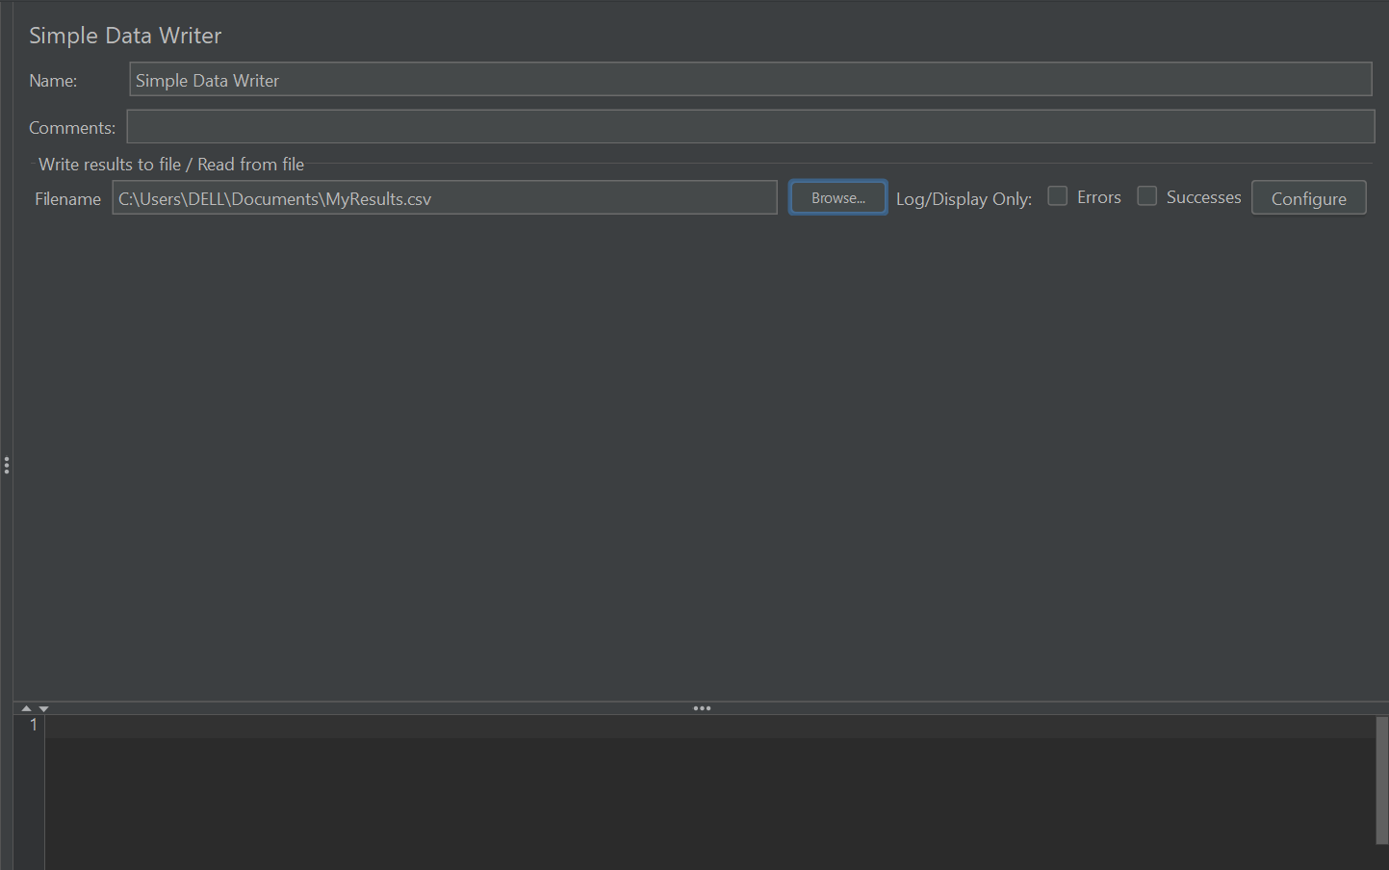

* **What it is:** Writes raw test results to .jtl/.csv/.xml file.
* **What it shows:** Sample results.
* **When to use:**
  + Generating HTML reports.
  + Offline analysis.
* **Example:** Run CLI test → store to results.jtl → generate dashboard.

**16. View Results in Table**

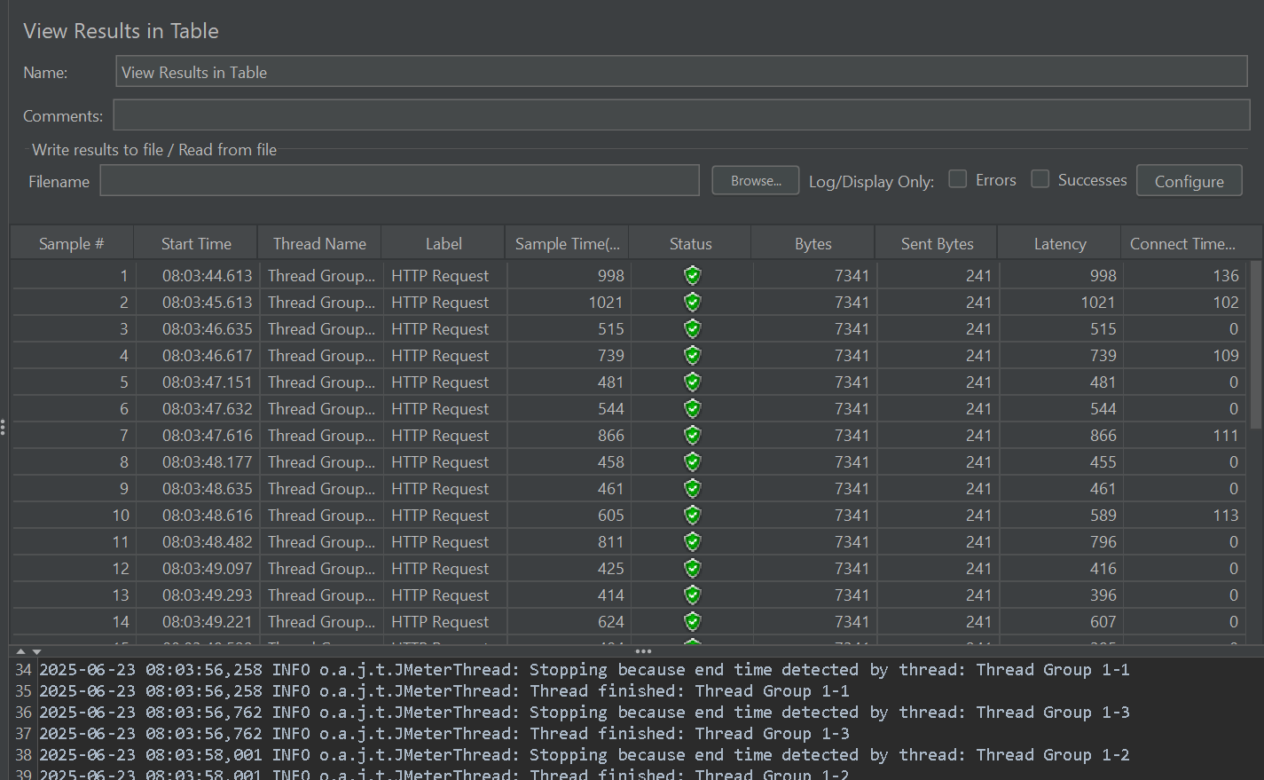

* **What it is:** Tabular sample view.
* **What it shows:** Per-sample row: Start Time, Elapsed, Code, URL, etc.
* **When to use:**
  + Quick identification of long or failed requests.
* **Example:** Sort by Elapsed → spot top 5 slowest.

**17. bzm - BlazeMeter Sense Uploader**

* **What it is:** Uploads results to BlazeMeter Sense.
* **When to use:**
  + If using BlazeMeter platform.
* **Example:** Auto-upload data → view in Sense dashboard.

**18. bzm - BlazeMeter Uploader**

* **What it is:** Uploads data to BlazeMeter.
* **When to use:**
  + Full BlazeMeter integration.
* **Example:** Launch local → upload results to cloud BlazeMeter.

**19. jp@gc - Rotating Simple Data Writer**

* **What it is:** Enhanced Simple Data Writer with file rotation.
* **What it shows:** Same as Simple Writer but across multiple files.
* **When to use:**
  + Endurance tests with huge data.
* **Example:** Rotate every hour → results_001.jtl, results_002.jtl, etc.

**20. BeanShell Listener**

* **What it is:** Custom scripting listener using BeanShell.
* **What it shows:** Scripted output/actions.
* **When to use:**
  + Java-style custom logic for results.
* **Example:** Log special warning if Login fails 3 times in a row.